Result:

This thesis aimed to improve the precision of brain tumor detection using MRI images. Several deep learning models such, as CNN, InceptionV3, Xception, EfficientNetB0, ResNet50 and VGG19 were. Analyzed. To ensure feature extraction and classification the dataset underwent pre processing techniques, like Augmentation, Gaussian Blurring and Sobel Edge Detection to optimize the quality of the images.  
  
Confusion Matrix:

Figure 1: Softmax Figure 2: SVM Figure 3: RF

Figure 4: KNN Figure 5: AdaBoost

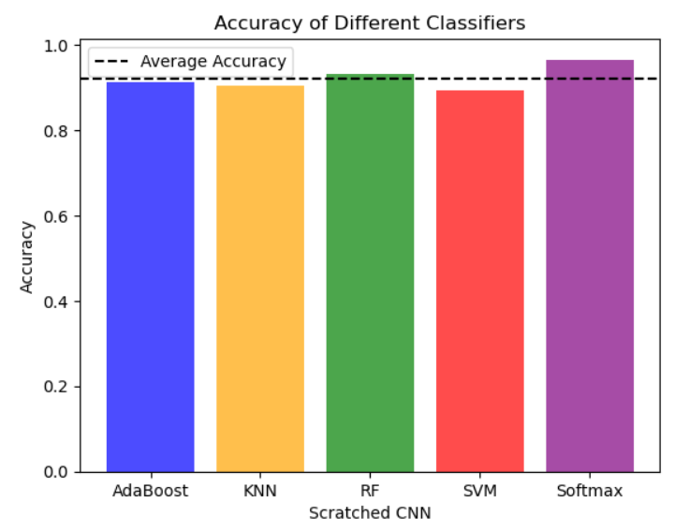 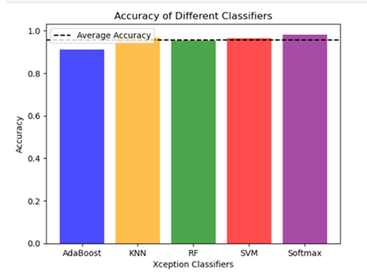

Figure 6: Scratched CNN Figure 7: Xception

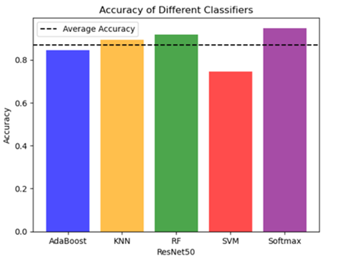

Figure 8: InceptionV3 Figure 9: RestNet50

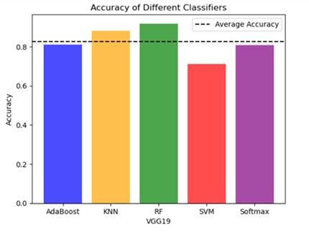

Figure 10: EfficientNetB0 Figure 11: VGG19

Various machine learning classifiers were used to evaluate the performance of six neural network (CNN) architectures. These architectures included Scratched CNN, Xception, InceptionV3, ResNet50 EfficientNetB0 and VGG19. Among them EfficientNetB0 showcased classification capability with the average accuracy of 97.87% and the lowest average log loss of 0.2571. On the hand ResNet50 demonstrated suboptimal classification performance, with the average accuracy of 87.03% and the highest average log loss of 0.4786. Xception and InceptionV3 performed competitively with accuracies of 95.47% and 96.27% respectively highlighting their effectiveness.

AdaBoost and Random Forest classifiers consistently achieved performance across all CNN architectures analyzed in this study. Support Vector Machines (SVM) and k Nearest Neighbors (KNN) however showed outcomes in terms of their performance.

Regarding log loss Softmax consistently exhibited performance, across all CNN architectures evaluated.

These findings underscore the importance of selecting a CNN architecture and classifier when performing image classification tasks. Amongst the models evaluated in this study EfficientNetB0 stood out as the performing model.

Combining 3 best-performing models with each other EfficientNetB0 + Xception, InceptionV3 + EfficientNetB0, InceptionV3 + Xception.

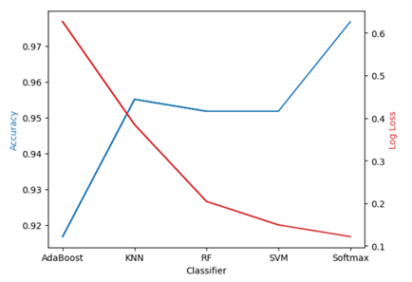

Figure 12: EfficientNetB0 + Xception Figure 13: Average Accuracy and Loss

EfficientNetB0 and Xception were combined for analysis. AdaBoost achieved an accuracy of 92.33% and a log loss of 62.84%. KNN performed better with 97.00% accuracy and a lower log loss of 13.72%. Random Forest and SVM displayed performance reaching, over 95% accuracy with log loss values. Notably Softmax stood out with the accuracy at 98.83% and the lowest log loss of 3.63%. On average the models achieved an accuracy of 95.90% with a log loss of 22.35% indicating high performance and reliable predictions, across different methodologies.

Figure 14: EfficientNetB0 + InceptionV3 Figure 15: Average Accuracy and Loss

In combined EfficientNetB0 and InceptionV3 architectures, AdaBoost model achieved an accuracy of 93.83% with a log loss of 62.51%. The KNN, Random Forest, SVM and Softmax models all showed accuracies ranging from 94.50%, to 98.67% with the Softmax model leading the pack. On average across all models achieved an accuracy of 95.87% and a log loss of 25.84%. These results demonstrate that our models performed overall with some models showing exceptional performance that makes them well suited for tasks requiring high predictive accuracy.  
  
Figure 16: InceptionV3 + Xception Figure 17: Average Accuracy and Loss

The combination of InceptionV3 and Xception, in machine learning models produced outcomes. AdaBoost demonstrated accuracy at 94.67% closely followed by KNN and SVM which achieved accuracies above 97%. Softmax performed well with an accuracy of 98.83%. The overall average accuracy of 96.87% and a low average log loss of 21.94% highlight the effectiveness of this architecture, in achieving accuracy and minimizing errors across different tasks.

Fron this 3 models picking best 2 for final model EfficientNetB0 + Xception and InceptionV3 + EfficientNetB0

Figure 18: EfficientNetB0 + Xception + InceptionV3 Figure 19: Average Accuracy and Loss

The combination of EfficientNetB0, Xception and InceptionV3, in machine learning models is a blend of deep learning architectures. This group of models has shown performance across classification tasks highlighting its effectiveness in achieving high predictive accuracy and minimizing errors.

AdaBoost, which is one of the methods achieved an accuracy rate of 94.67%. This demonstrates its capability to enhance the performance of learners. Additionally the low log loss score of 61.89% indicates that it can provide accurate probability estimates with consistency.

K Nearest Neighbors (KNN) displayed an accuracy rate of 97.33% indicating its proficiency in classifying data points based on their proximity in feature space. The corresponding log loss score of 17.41% suggests that KNN provides calibrated probability estimates.

Random Forest (RF) an method achieved a strong accuracy rate of 96.33%. Its log loss score of 17.78% indicates reliable probability estimation abilities making it a dependable choice for classification tasks.

Support Vector Machine (SVM) exhibited an accuracy rate of 97.50%. With a log loss score, as 6.13% SVM not only demonstrates accurate classification but also provides calibrated probability scores effectively.

Softmax, a learning technique achieved an impressive accuracy rate of 98.67% and demonstrated a remarkably low log loss of 4.44%. This clearly emphasizes the capability of networks to capture intricate patterns, within data.

Ensemble methods have been utilized to combine the abilities of EfficientNetB0, Xception and InceptionV3 models. This combination has resulted in a performance that accurately reflects the capabilities of classifiers. The final accuracy metric, for this approach stands impressively at 96.90% highlighting the effectiveness of merging models to enhance accuracy.

It is worth noting that there can be conflicting outputs among classifiers when analyzing a MRI image, which can pose challenges to achieving predictive accuracy. Despite these obstacles the ensemble model offers an approach towards achieving accuracy in identifying brain tumors in MRI images. These results affirm that deep learning techniques advanced CNN architectures and ensemble methods play a role in improving healthcare outcomes for individuals suspected of having brain tumors.

This outcome demonstrates the effectiveness of learning models in detecting brain tumors. The high rates of accuracy attained by these models suggest their potential for applications. Further validation and refinement are necessary to ensure performance in real world scenarios. This research contributes insights into the application of AI, in diagnostics specifically within the critical field of brain tumor detection.